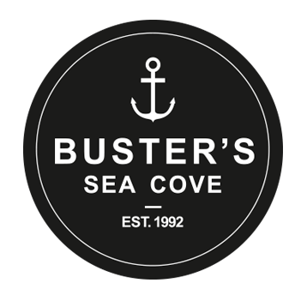
Buster’s Sea Cove Wedding/Special Event Menu

- Atlantic Lobster Roll served with fries & coleslaw

- Lobster Grilled Cheese served with fries & coleslaw

- Grilled Salmon served with rice & seasonal veggies

- Halibut and chips served with coleslaw & homemade tartar sauce

- Grilled Jumbo Tiger Shrimp served with rice & seasonal veggies

- Grilled Halibut served with roast potatoes & seasonal veggies

- Seared Ahi Tuna served with salad

Salads are also available as a substitute side
Key lime pie in a mason jar is available as a dessert option ($9/person)

